Plotting report:

Part 1:

The plotter is pretty much straightforward.

Thanks to my PS2 teacher, he taught me to read and write into a csv file at the end of semester. Luckily it was the previous semester so it’s still kind of fresh.

I originally chose the combination formula, but then changed it to cos(x).

It’s easier and looks fun with the salter.

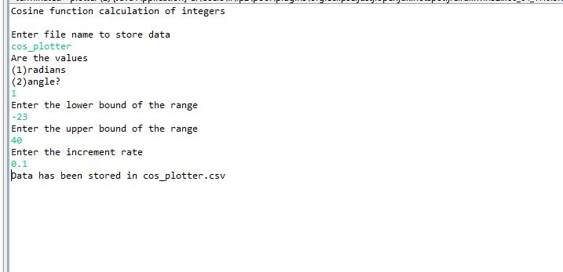

This is the full process of my plotter

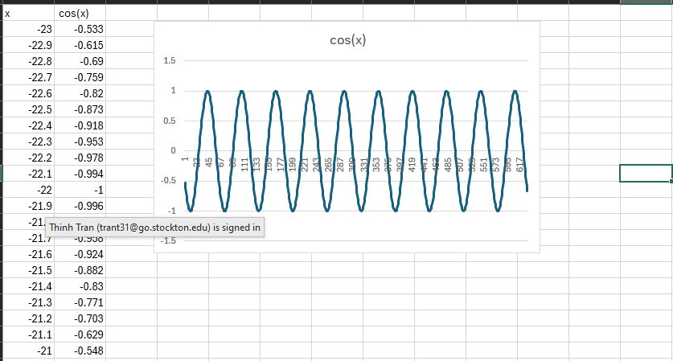

This is the result csv file and the graph.

I noticed that when dealing with small numbers, you have to take care of close comparator, like 19.9989 < 20. That’s considered equal so at first I was missing the last number, so I added something called “insurance” with a very low value of 0.00000001. To counter that, it worked! So, I don’t touch it ever again.

I fix it with a format method when it’s ready for output.

Salting:

Follow the instructions, I ask the user for a range to salt, as low as salt Bae and high as Hell kitchen Ramsey.

With the above plotter, this is what I got:

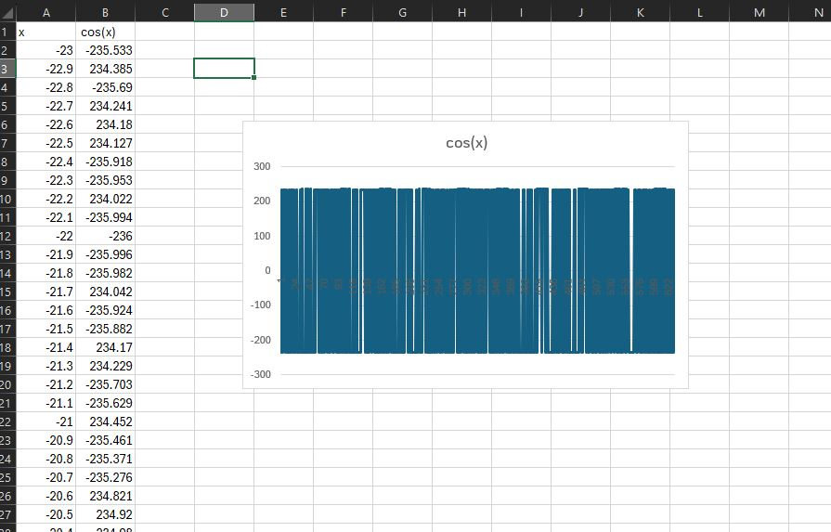

Smoother:

Pretty straight forward, I take in the salted data and smooth with using moving average.

This is after the smoothing process:

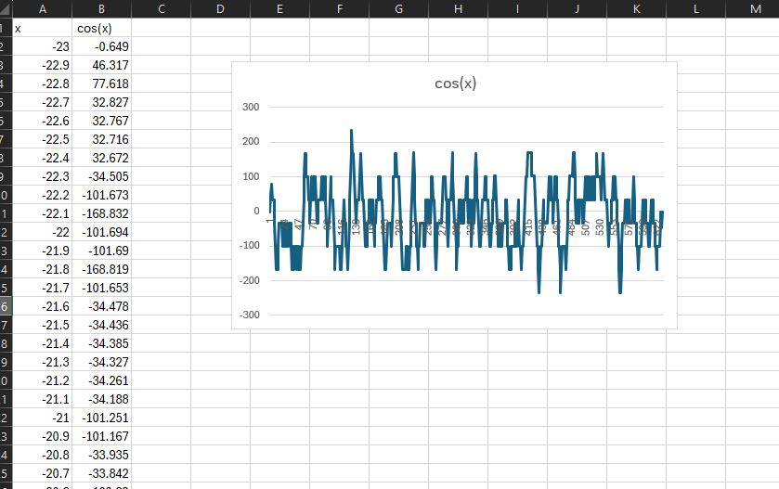

And this is after 2 more smoothies:

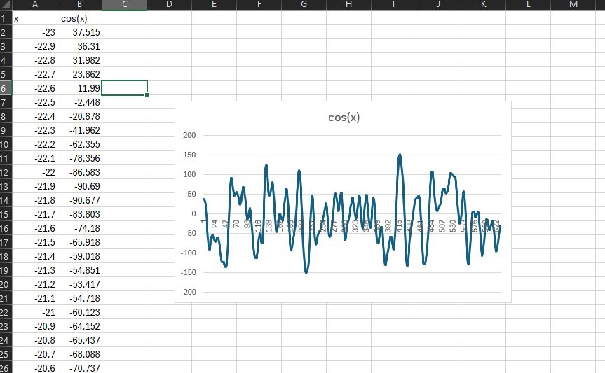

And this is after another 3 smoothies:

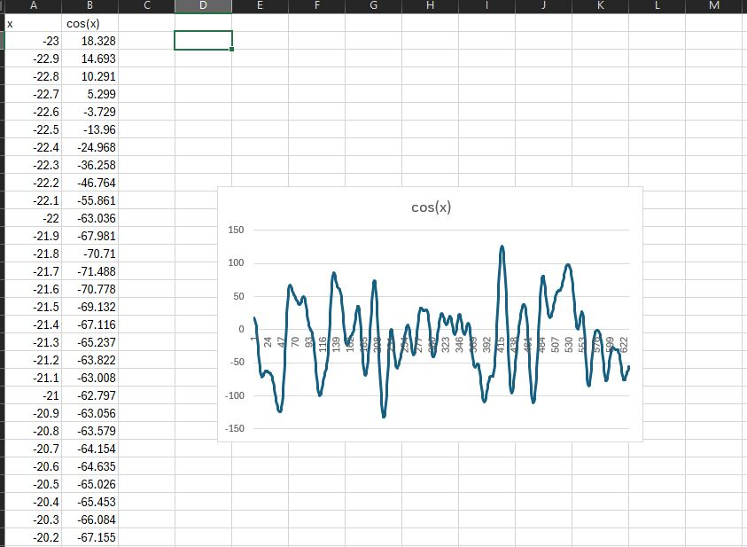

The graph pretty much stayed the same, huh.

Part 2: MatLab PSS

I use Matlab since we can access Stockton’s computer through a VDI

I didn’t do much of practice per say, I watch youtube tutorials though, oh and look through the main website of Matlab: [2-D line plot - MATLAB plot (mathworks.com)](https://www.mathworks.com/help/matlab/ref/plot.html)

[How to Use Basic Plotting Functions (youtube.com)](https://www.youtube.com/watch?v=GtmUXVzw4lQ)

[Matlab Basics: Reading and Writing CSV Files (including from Excel) (youtube.com)](https://www.youtube.com/watch?v=GQtYAT36CZ4)

[Grammarly Basics: What You Can Get for Free (youtube.com)](https://www.youtube.com/watch?v=6EtYTUDcgSA)

[Write A Winning Essay | Better Grades With Grammarly (youtube.com)](https://www.youtube.com/watch?v=4ne3caazhkE)

I don’t know if you only want us to graph it or also write it so I did it like part 1.

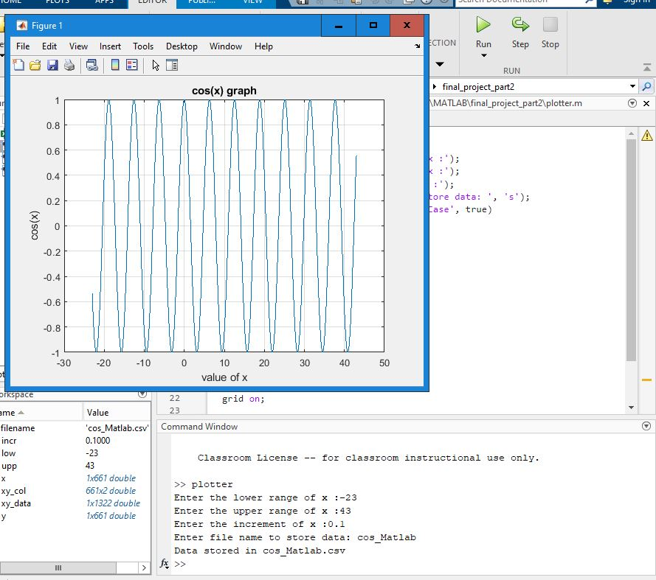

Salting:

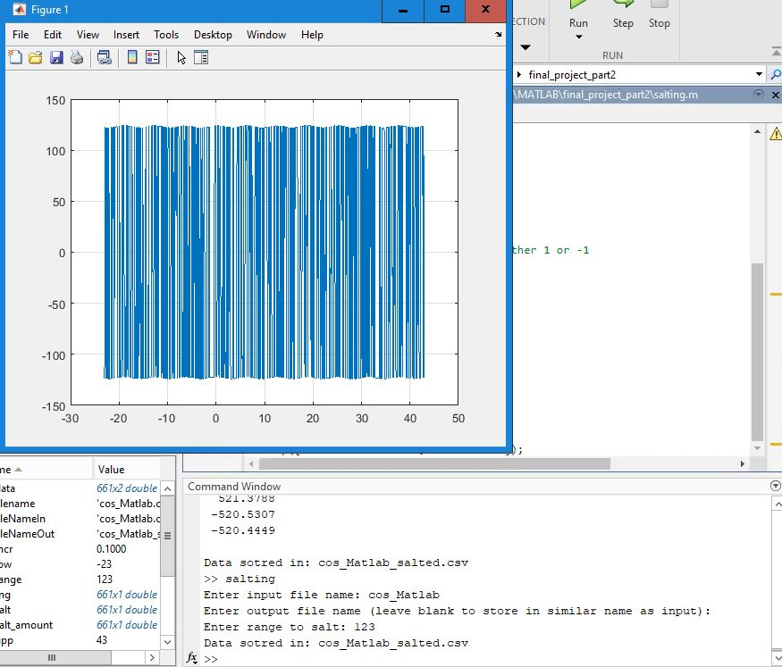

Smooth:

This one took me quite sometime, just to get the average moving is quite tiring. But I got it in the end.

Doesn’t look quite good tbh.

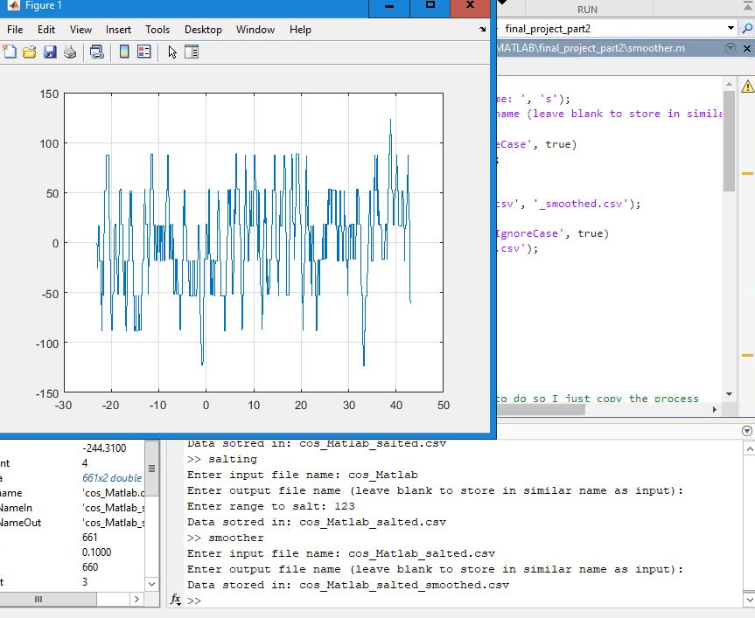

Part 3: PSS with graph

This one is just the part 1 but with graphs, and so that’s what I did.

I copied part 1 and import JfreeChart through maven and graph it using.

I ask for user inputs and do it, then store them into a csv file and graph it.

This is the result:

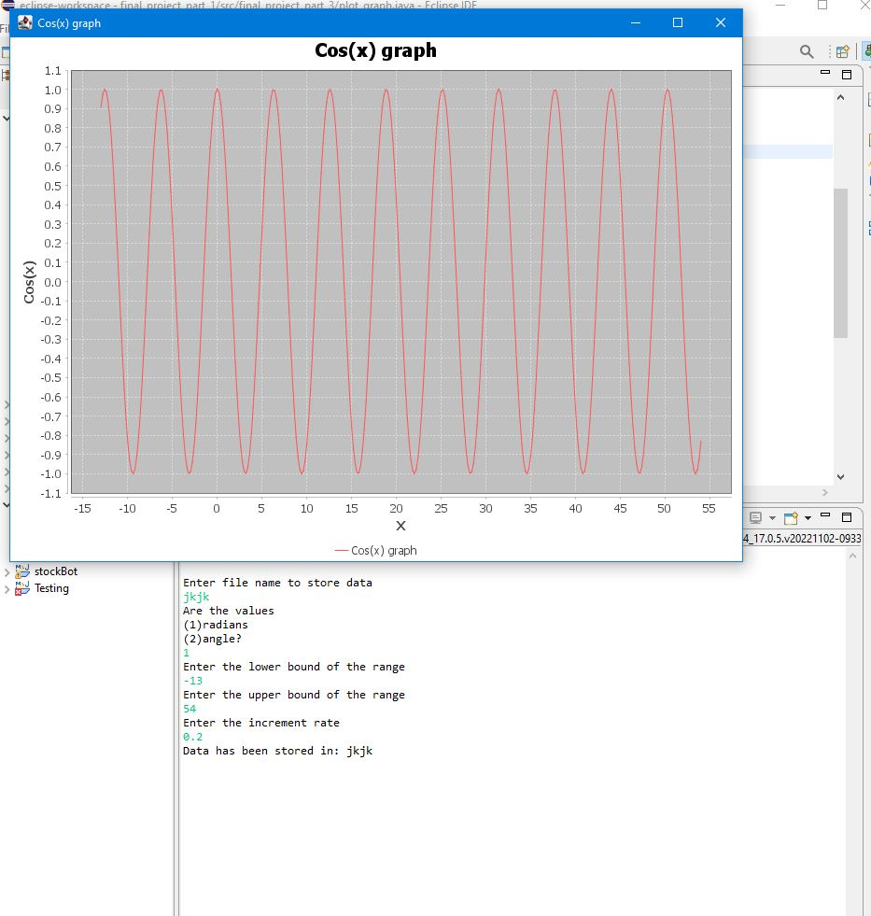

Salting:

Pretty much the same.

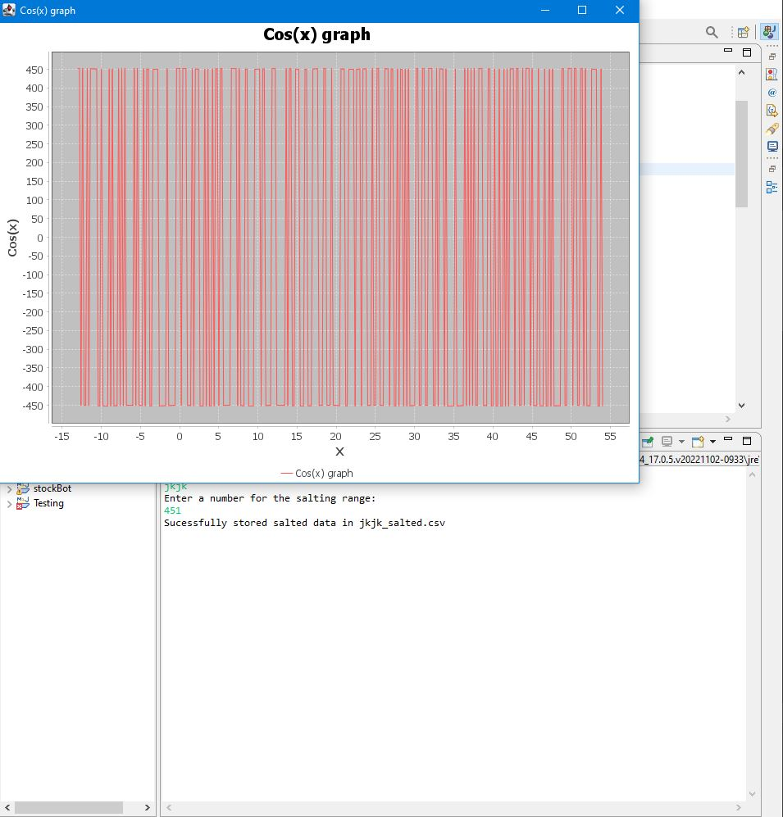

Smooth:

Pretty much as expected

